建堂籌款和代禱信

主內弟兄姐妹， 願你們平安！
在 7 月 20 日，我們教會牧者、職員會和尋找教會物業的團隊已分別參觀了位於 Fishponds 的教會物業。大家一致認同此地方在各方面都能滿足我們的需求，故作出以下購買此教堂的建議，

物業資料:
為前衛理公會教堂和社區房間的單一建築。它位於 Fishponds 的住宅區內，靠近大街和主要巴士路線。總樓面面積計算為 684 平方米 (7360 平方英尺)。並有多個停車位。
該物業以非正式招標方式出售，並於 2021 年 8 月 2 日星期一中午前以書面形式提出標書。
由於教會提議出價為最少 550,000 英鎊，教會可動用的資金為 200,000 英鎊，因此需要籌集最
少 350,000 英鎊。希望大家禱告後作出以下的選擇, 並在 7 月 28 日前交回教會司庫以計算可運用的資金。

你可以如何參與？

1. 為籌建和投得此物業禱告 2. 一次性奉獻 3. 無息貸款
請祈禱並在下面註明您的承諾數字和方法。然後直接發回給教會司庫 Michael Ho :
可透過發送電子郵件：bristolccc.uk@bristolccc.org
或將完成的承諾認獻表格以 whatsapp 發送給 Michael Ho 或可填妥表格後並放入信封內交給小組長轉交給 Michael Ho 。

認獻表格
奉獻數目 (一次性)：500 英鎊 □ 1,000 英鎊 □ 2,000 英鎊 □ 5,000 英鎊 □
或其他數額 - 請註明:
無息貸款： 1,000 英鎊 □ 2,000 英鎊 □ 5,000 英鎊 □
或其他數額 - 請註明:
無息貸款還款期: 6 個月 □ 一年 □ 二年 □ 或其他時限:

以上任何認獻的數目需要在教會能成功投得此物業後，將會通知大家在 28 日內存入教會的户口。

姓名及簽署: Gift Aid No. 退稅編號:

聯絡電話:

聯絡電郵地址:

Church building fundraising and prayer letter
Dear brothers and sisters,
Shalom, may peace be with you！
On the 20th July 2021, our pastoral workers, church council and property seeking team has viewed the property located in Fishponds. We unanimously agree that the site meets our specifications in all aspects that we have considered. So we recommend the following actions in order to proceed with the property purchasing.

Information about the property:
A single building previously used as Methodist church and community rooms. It is located within the residential areas in Fishponds, close to main road and bus lines. Total floor area is 684 sq. meters (7360 sq ft). It will include several off road parking spaces.
The building is sold by informal tender bidding, offers are due by noon on Monday 2nd August 2021.
The church proposes a bidding price of at least £550,000. As the church's current available funds are £200,000,so we would need to raise at least £350,000. We hope everyone could prayerfully consider the options below and return the pledge form to our Church's Treasurer by
28th July 2021 in order to calculate our total usable funds.

How can you be involved?
1. Pray for the fund raised and bidding of this building 2. One-off contributions
3. Personal Loan (interest free)
Please prayerfully consider and tick the boxes below the amount you would like to pledge and the method of contribution. Then return the form back to our Treasurer Michael Ho.
You can do this via emailing: bristolccc.uk@bristolccc.org
Alternatively, send the completed form via Whatsapp to Michael Ho or seal the form within an envelop handing to your small group leader to pass on to Michael Ho.

Pledge Form
Offering amount (One-off): £ 500 □ £ 1,000 □ £ 2,000 □ £ 5,000 □
Or other amount, please state:
Personal Loan (interest free): £ 1,000 □ £ 2,000 □ £ 5,000 □
Or other amount, please state:
Expected Repayment Period: 6 Months □ 1 year □ 2 years □
Or other period, please state:
Once the church has won the bid, we will notify you of the method of transferring the pledged amount into the church's bank account within 28 days.
Name & Signature: Gift Aid No:

Contact number:

Contact E-mail Address :

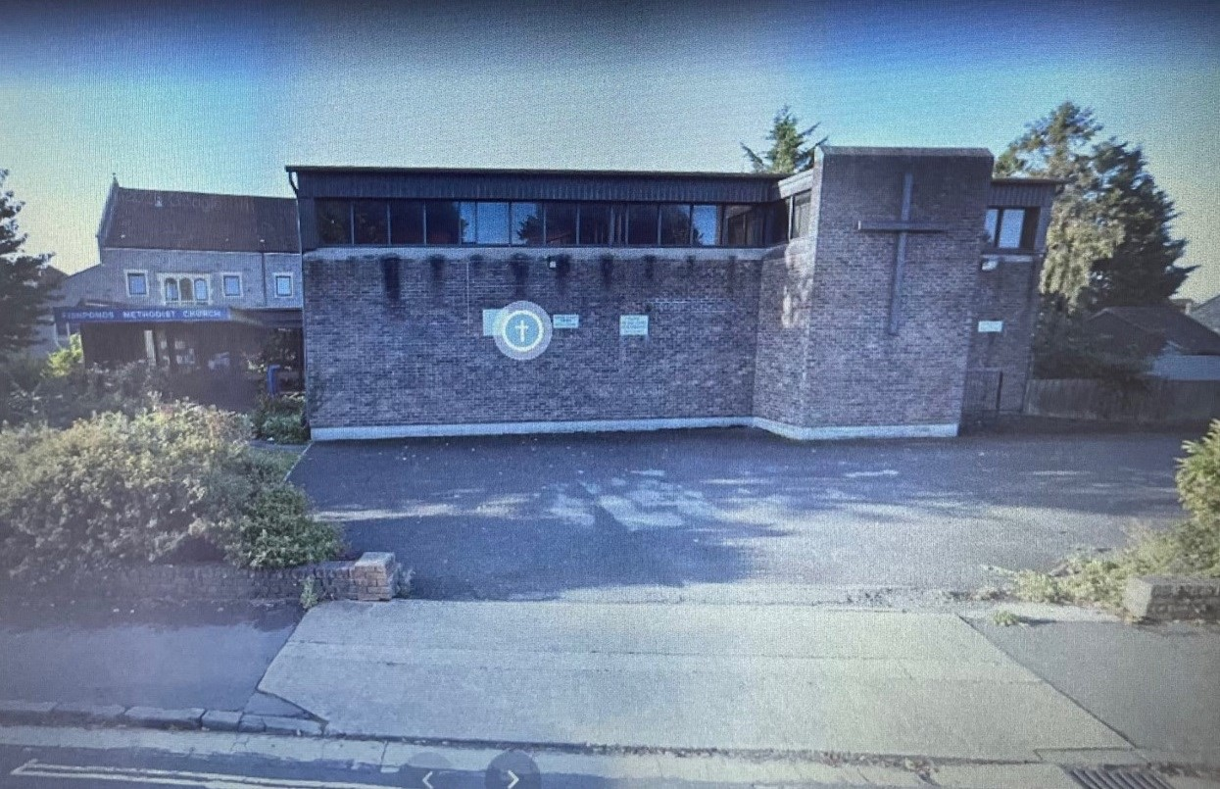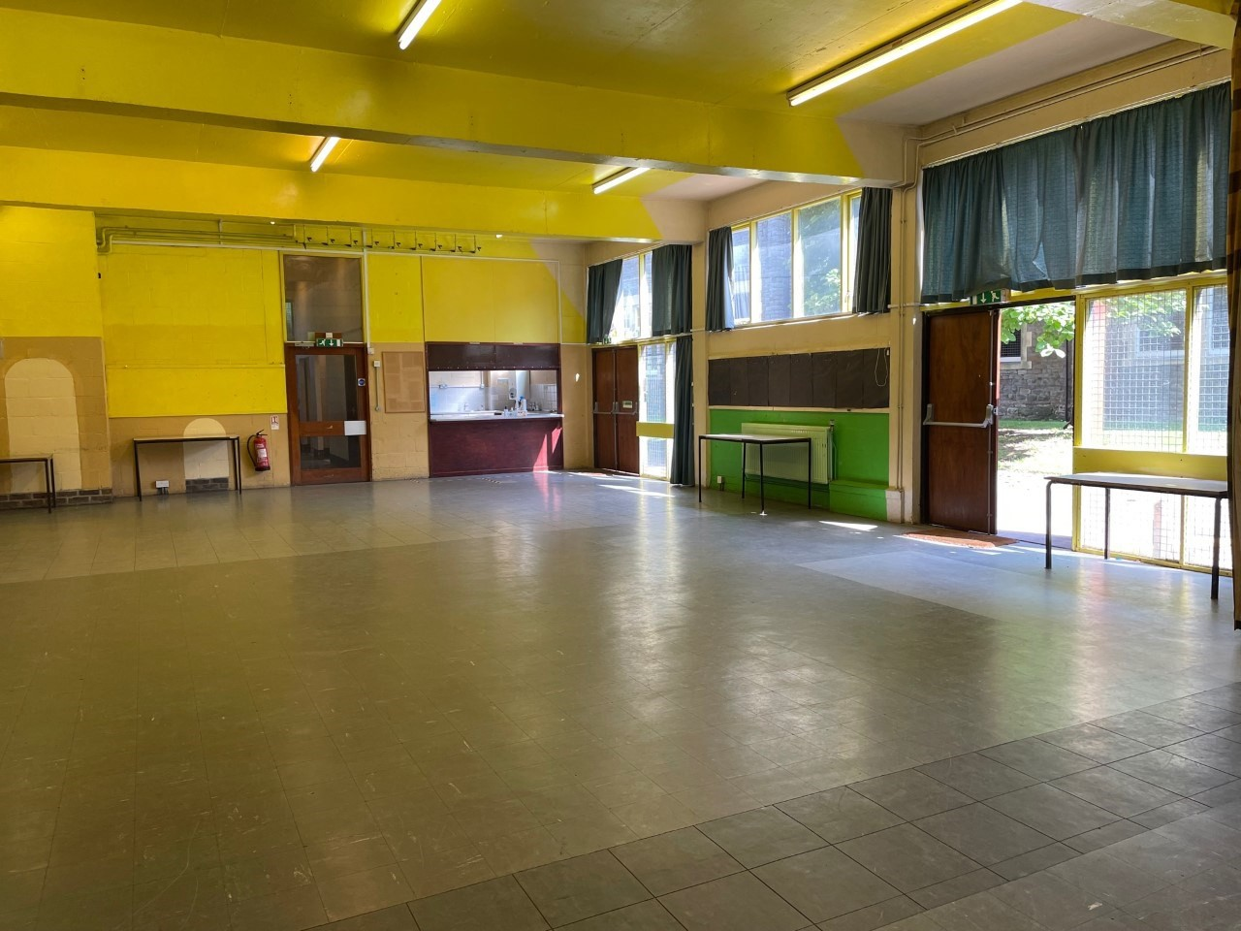Church property location : 22 Guinea Lane, Fishponds, Bristol BS16 2HB
Function room downstairs 樓下大堂
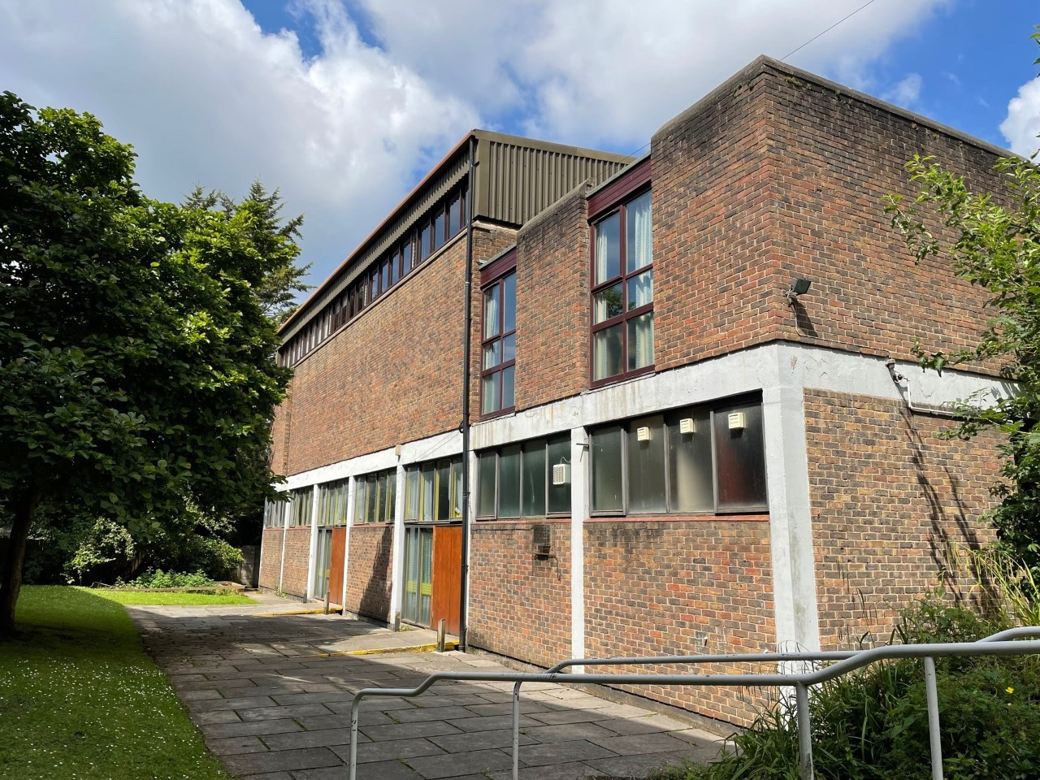More photos can be found from : https://www.perrybishop.co.uk/Property/Details/23401
Rear of the church 教堂後部
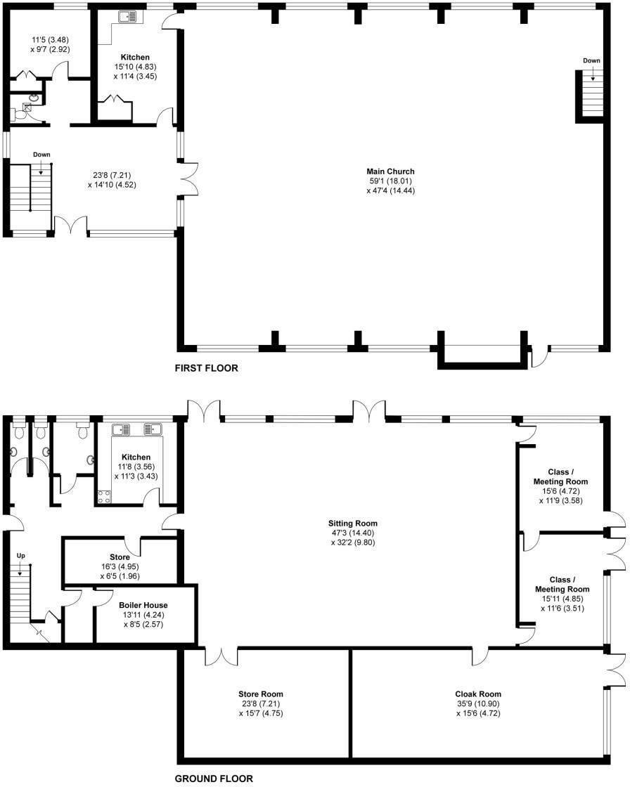
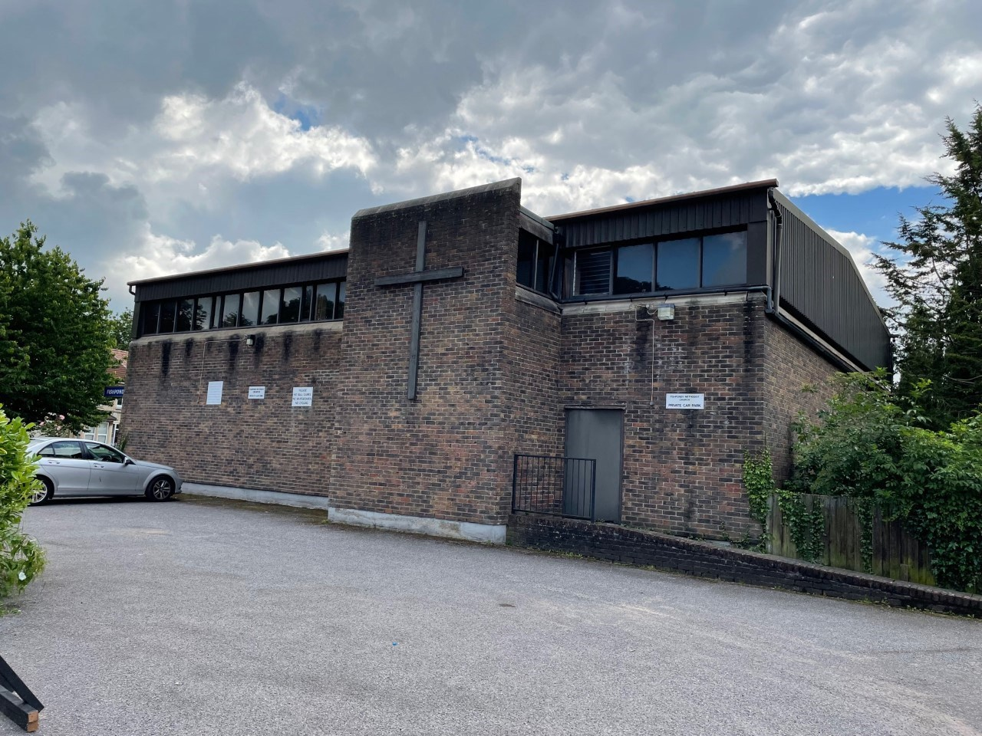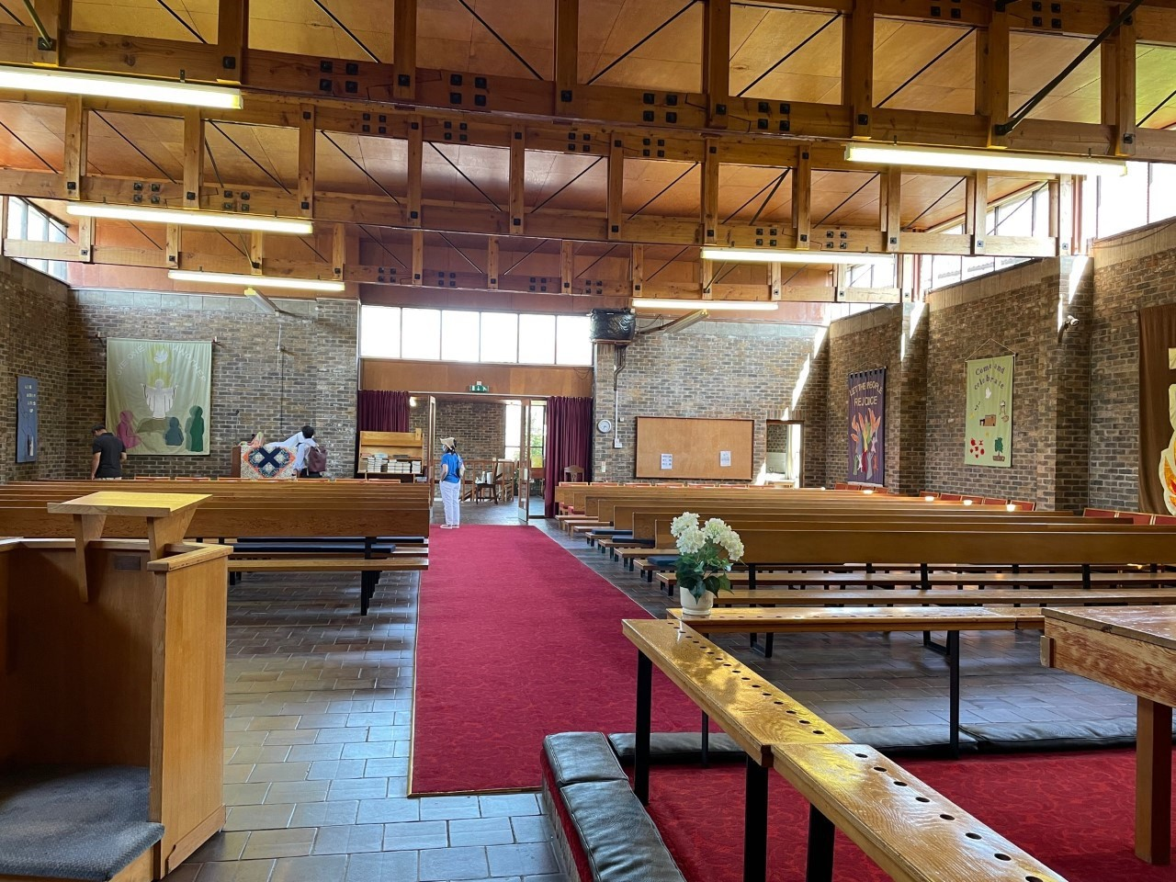
Front of the church 教堂前部
Sanctuary 主教堂

